Dorsey Metrology International | Deterco, Inc.
Model 24P Unpacking Instructions | Deterco, Inc.

Tools needed:
Fork Lift capable of lifting 4000 Lbs.
Electric Drill/Driver with a 9/16 socket attachment or a 3/8” Drive ratchet with a 9/16 socket and 6” extension.
Set of Metric hex wrenches.
Set of inch Hex wrenches.
Large flat blade screwdriver approximately 12” long.
10” or 12” crescent (adjustable) wrench.
Razor knife to cut plastic wrapping.
3’ to 6’ step ladder to remove top of crate.
Simple spirit level. A “Torpedo” level will do.

The 24P is packaged in a wooden crate. You will need to remove the top then the four sides. Then remove the machine from the pallet. Only when the machine is in its permanent location should you remove the machine Axis locks.
Unpacking procedure.
Inspect the crate for obvious signs of shipping damage. Take pictures and report any shipping damage to the trucking company. The unpacking should be done with at least two people. The sides of the crate are held in place with clips and Lag bolts at the bottom of the panels. Remove all of the lag bolts using a 9/16 socket and an electric drill/driver. Or a ratchet and socket. Using a long flat blade screwdriver, pry off the metal clips holding the top of the crate on. Remove the crate top and place it aside out of the way. Remove the clips holding on one of the smaller box ends. Remove the end and place aside. Remove the clips holding one of the larger sides on and place the side out of the way. For the last two panels hold both of them. While removing the clips to prevent them from falling against the machine. When separated place them out of the way. Again, take a quick look for obvious shipping damage.
The machine is wrapped in treated rust inhibiting protective plastic. Remove only this plastic wrap by pulling it away from the machine and cutting it with a razor knife. Do not cut against the machine or the boxes under the plastic. Do not remove the three axis locks that are on the machine. These keep the moving parts from being damaged while the machine is moved. The three axis locks are as follows. The X-axis stage (table) is locked with plastic spacers between the top and bottom sections and yellow tags marking the locking bolts. Do not remove at this time. The focus-axis is locked with two locking plates marked with yellow tags. Do not remove at this time. The Y-axis is locked with wooden blocks and protective bubble wrap. Do not remove the Y-axis wooden blocks at this time. Once the protective wrap is completely removed, you can thoroughly inspect for any shipping damage. If damage is present take pictures and immediately report this to the Transportation Company and Dorsey Metrology International. DO NOT CONNECT THE ELECTRICAL CORD AT THIS TIME.

Place all of the boxes and equipment that shipped in the crate out of the way in perperation to remove the machine from the pallet base. At this point please use your packing list to make sure all of the equipment that was shipped is acounted for. Do not discard any packing material until Everything is accounted for.

The machine is bolted to the pallet with four carriage bolts. Remove the nuts from the carriage bolts. You’ll need to lift the comparator off of the pallet with a forklift place the forks under the machine from the side. Most of the weight is towards the front of the machine. So place the forks more towards the front of the machine. Tap the carriage bolts down to help remove the machine from the carriage bolts. Lift the machine, and slide the pallet out from underneath the machine. Lower the machine almost to the floor. Move the machine into the area where it is going to be used and position it in place. Place a small spirit level on the stage top and level the machine by adjusting the feet with the crescent wrench. When the machine is level swing the mounting brackets under the machine and tighten up the locking nuts on the feet.
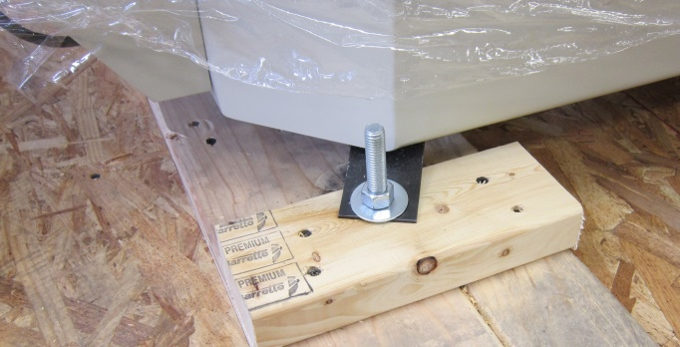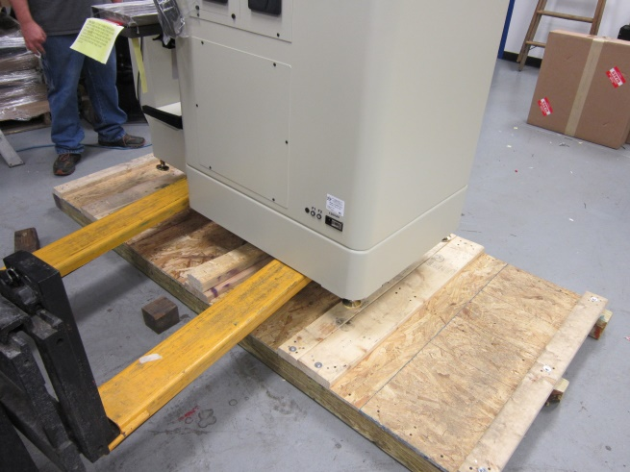

With the machine in place and level you can now unlock the three axes. Start by removing the two focus axis locks, located near the focus bearings. There are two metal plates one on each side indicated by paper marker tags. They have two screws holding each plate. Remove the four screws and two plates.
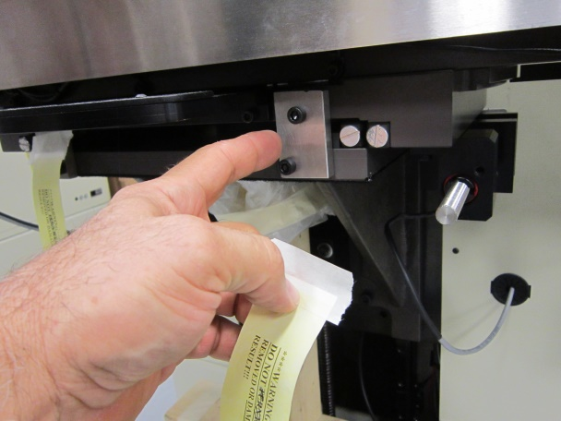

Next remove the X axis locks from the stage. The X axis locking system consists of two plastic spacer and two locking screws. The X axis locking screws are located one under each side of the stage and are indicated by paper streamer tags. The plastic spacers are located between the stage top and bottom and keep the two plates separated for shipping. Remove the two locking screws from under the stage. Then pull the plastic spacers out from between the stage top and bottom while holding up slightly on the upper half of the stage. Holding up with slight pressure will keep the two stage plates from banging together when the plastic spacer is removed.
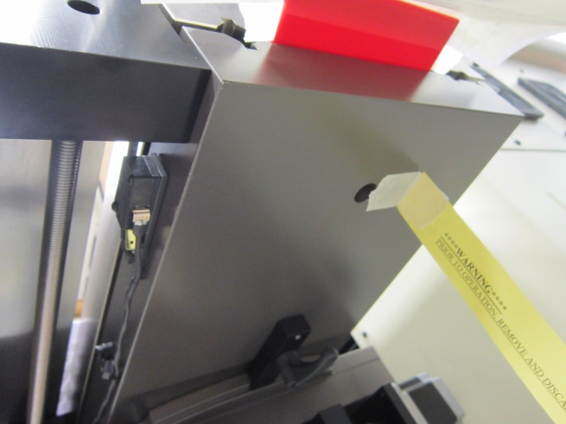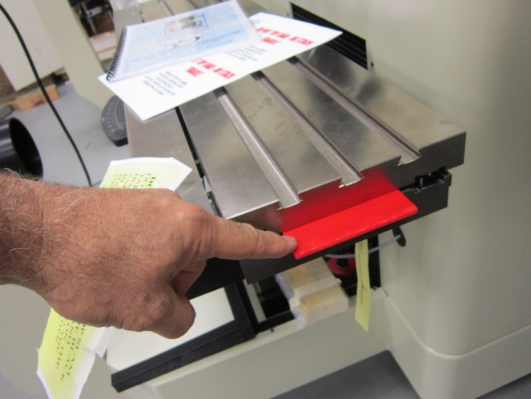

Locate the Joystick and connect it to the joystick cable. Attach the joystick to the lamphouse using Velcro. Connect the optical comparator power cord to the machine and to a wall outlet. A standard 15 Amp. wall outlet is fine. Turn on the machine main power.(Red Switch)Using the joystick pull the joystick lever back to you to raise the stage assembly (The Y Axis) then remove the woden shipping block. CAUTION! MAKE SURE YOU ARE RAISING THE Y-AXIS TO REMOVE THE BLOCK. When the Y axis shipping block is removed, put the bellows in place by attaching it to the Velcro on the base of the machine. Attache the top of the bellows to the underside of the knee assembly near the stage bottom.
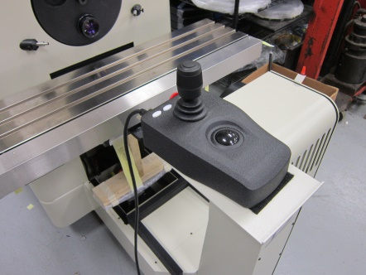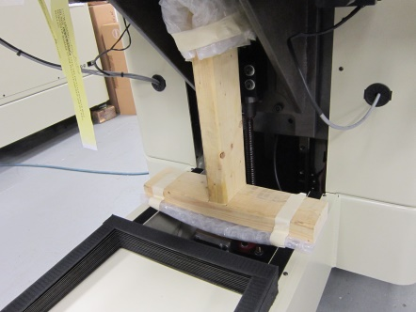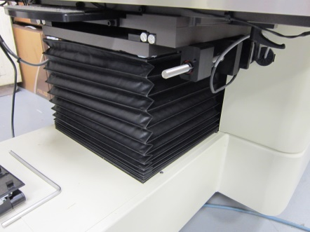

Test the lights and joystick. Make sure the lens is located In the proper orientation for the turret. Mountd the readout arm to the side of the case using the four M4 screws provided. Install the readout onto the arm. Connect the readout cables acording to the labeling and picture. Turn on the digital readout with the toggle switch located behind the unit.
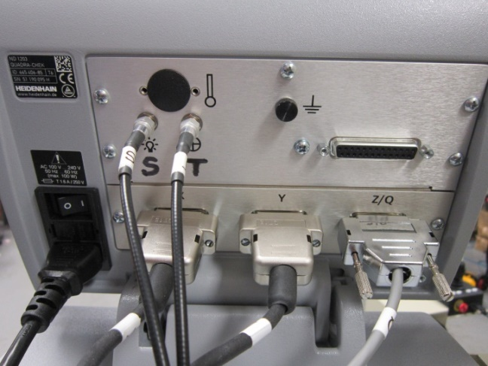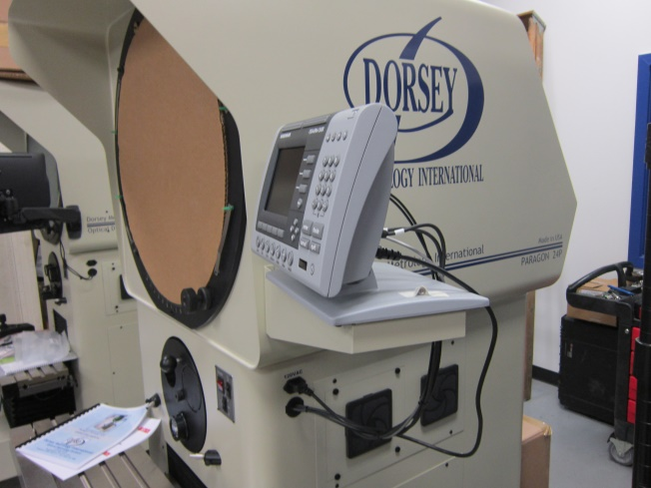

Screen Installation 24P

To install the screen on a new 24P comparator, first remove the two “Cam Rollers” located at the top of the chart ring. Remove the large cardboard cover from the screen opening.
Unpack the new screen from its box and hold it securely around the edges. Try not to get fingerprints on the glass. If you have good fitting vinyl gloves you can use them to avoid fingerprints on the glass. Holding the screen vertically, place the new screen into the lower screen roller and drive wheel. With the glass securly in the two lower rollers. Hold the screen at the top with your right hand and lift up the spring loaded brass wheel with your left hand. Tilt the screen back under the groove in the brass wheel. Gently lower the spring-loaded brass encoder wheel onto the edge if the screen. Be sure the edge of the glass is in the brass wheel groove. If the glass is not in the groove, the brass wheel can snap down and chip or break the glass. Once the new screen is in place, replace the two Cam roller assemblies. To do this, first install the outer roller section with the cam insert, then insert the M6 screw. Screw the M6 screw in but leave it loose. Rotate the roller cam counter clockwise until the wheel just touches the glass. Then tighten the M6 screw. If the cam moves a little during tightening, the wheel will get looser. (this is OK) Do this for both top cam rollers. Check for proper operation and screen rotation. Adjust the cam rollers if needed. A little looser is better than too tight. The top cam rollers do not need to roll all of the time they are a guide. Do not rotate the roller cams clockwise. This will put extra pressure on the glass when you tighten the M6 screw.
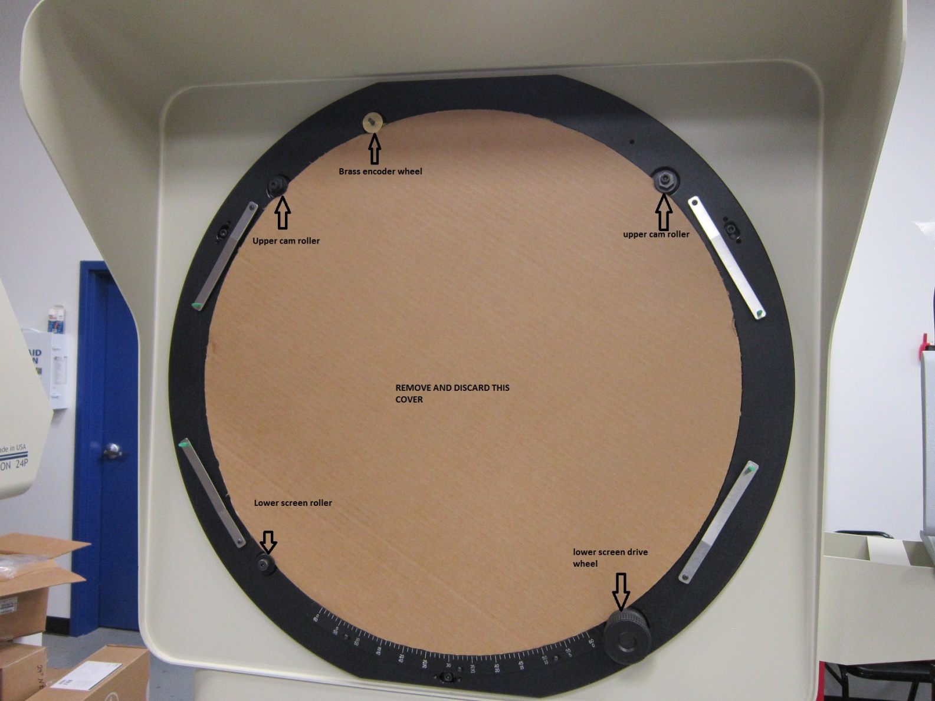

Your optical comparator has been fully inspected and certified at the factory. Once the machine is in place at your facility a “calibration verification” should be performed by a qualified individual to make sure everything is within specifications and nothing has changed during shipping and setup.
For questions or technical assistance please call Dorsey metrology international at 845 454-3111 ext 114 or ask for someone in the optical department.

